Infosys Springboard internship
AirAware project

NAME: SHARMIKA GANGADHARAN
BATCH: 6
STARTING DATE: 10 NOVEMBER 2025

Day 1:
Project Name: AirAware – Smart Air Quality Prediction Systems
- This project focuses on predicting and monitoring air pollution levels using machine learning and data analysis.
- You will choose your own tools for the frontend, backend, database, and dataset.
- The system will work with pollution indicators such as PM2.5, CO₂, NO₂, and others.
- You can also collect live environmental data from platforms like HuggingFace or Kaggle, where datasets often include values such as O₂, NO₂, and CO₂.
- Over the next 45 days, your task is to build a system that can study historical air-quality data, forecast future pollution conditions, and create visual insights.
- The goal is to generate alerts whenever harmful or risky air-quality levels are detected.

Priorities
- Use 3–4 months of air-quality records and display the analysis on a dashboard.
- Gather datasets containing pollution metrics (PM2.5, CO₂, NO₂, etc.) and store weather-related inputs in a database.
- Clean and preprocess the collected data (normalization, noise removal) before training any model.
- Build models such as SVM, Random Forest, or Linear Regression to perform predictions.
- Compare the forecasted values with actual pollution levels to check accuracy.
- Retrieve weather conditions from external sources when needed and save them for reference.
- Set up the backend and database to manage data flow and support the prediction system.

DAY – 2
API AND ITS TYPES
1. What is an API?
API (Application Programming Interface)
A set of rules that allows two software applications to communicate with each other.
Example: Your mobile app talks to a backend server using an API.
1. FLASK API
Flask is a lightweight Python web framework used to build APIs.
Example Flask API code:
from flask import Flask, jsonify
app = Flask(__name__)
@app.route("/hello")
def hello():
return jsonify({"message": "Hello API!"})
2. How to import in Flask
from flask import Flask, request, jsonify
You import:
- Flask → to create the app
- request → to read data sent by the client (payload)
- jsonify → to return JSON responses
3. FASTAPI
FastAPI is a modern, fast (high-performance) web framework to build APIs.
Example FastAPI code:
from fastapi import FastAPI
app = FastAPI()
@app.get("/hello")
def hello():
return {"message": "Hello from FastAPI!"}
FastAPI is faster than Flask and supports async functions.
4. Payload
Payload = the data sent from client to server
Example JSON payload:
{
"username": "john",
"password": "1234"
}
Usually sent in POST or PUT requests.
5. Postman
Postman is a tool used to:
- Test APIs
- Send GET, POST, PUT, DELETE requests
- Add headers, params, and payload
- View server responses
6. WebSocket
WebSocket = a connection where server and client talk continuously in real-time.
Used in:
- Chat applications
- Stock price streaming
- Live tracking apps
FastAPI supports WebSockets easily.
7. Streaming
Streaming means sending data continuously instead of all at once.
Examples:
- Video streams
- Audio streams
- Live API responses (server pushes small chunks)
8. Flashing (Flask Flash Messages)
Flask flash messages are temporary messages shown to the user.
Example:
from flask import Flask, flash, render_template
flash("Login successful!")
Used in user notifications like:
- Success
- Error
- Warning

DAY – 3
GIT COMMANDS
1. git add .
Adds all files to the staging area.
2. git add main.py
Adds only main.py to staging.
3. git commit -m "message"
Creates a commit with a message.
4. git push
Uploads your commits to the remote repository (GitHub).
5. git branch --all
Shows all branches including remote.
6. git branch
Shows local branches.
7. git fetch --all
Downloads all branches from remote without merging.
8. git pull
Fetch + merge (updates your local code from remote).
9. git checkout -b "sh_new"
Creates a new branch sh_new and switches to it.
10. git checkout "sh_new"
Switches to the sh_new branch.
13. requirements.txt
List of all Python libraries for a project.
Example:
flask
fastapi
uvicorn
requests
pydantic
14. pip install -r requirements.txt
Installs all libraries inside requirements.txt.
15. deactivate and shut the venv
If you are using a virtual environment:
Deactivate
deactivate
Delete the environment (optional)
rm -r venv

DAY – 4
Database
1. Database Languages

DDL (Data Definition Language): Used to create, modify, and remove database structures such as tables.

DML (Data Manipulation Language): Operations used to insert, update, retrieve, or delete records stored in the database.

2. CRUD Operations
CRUD represents the basic actions performed on data:
Create – Add new data or records
Rename – Modify the structure or name (Alter/Rename)
Update – Change existing data
Delete – Remove data

3. Types of Databases
Structured Databases
These use tables with rows and columns. Examples:
MySQL
SQL
PostgreSQL

Unstructured Databases
These handle flexible, document-based or non-tabular data. Example:
MongoDB

4. Normalization
Normalization helps reduce redundancy and organize data efficiently.
1NF (First Normal Form): Each column should contain atomic (indivisible) values.
2NF (Second Normal Form): Data must depend entirely on the primary key.
3NF (Third Normal Form): No transitive dependencies between non-key fields.
BCNF (Boyce–Codd Normal Form): Every determinant must be a candidate key.
4NF (Fourth Normal Form): Removes multi-valued dependencies.
5NF (Fifth Normal Form): Breaks tables into smaller ones without losing information.

DAY – 5
AI CONCEPTS
1. AI Models, Platforms & Major Companies
A. Google – Gemini Models
Google builds the Gemini family of AI models, designed for advanced multimodal tasks.
Gemini Variants
- Gemini Nano → Lightweight model for mobile/on-device use
- Gemini Pro → Cloud-based model for applications
- Gemini Ultra → High-end model with strong reasoning abilities
Key Abilities
- Understands text, images, audio, and video
- Supports coding, analysis, and content creation

B. OpenAI – GPT Models
OpenAI develops the GPT (Generative Pre-trained Transformer) models.
GPT Model Versions
- GPT-3.5
- GPT-4 / GPT-4o
- GPT-4.1 / GPT-5 series
- Used in products like ChatGPT, DALL·E, Assistants API, etc.
Uses
- Chatbots
- Coding assistance
- Content generation
- Language translation
- Data analysis
2. LLM Basics (Large Language Models)
LLM = Large Language Model
A model trained on large datasets to understand, generate, analyze, and process natural language.
Capabilities
- Text generation
- Summarization
- Code writing
- Q&A
- Reasoning
- Translation
3. AI Platforms for LLMs
A. Google AI Studio
A platform for using and testing Gemini models, offering:
- Prompt creation
- Model comparison
- API testing
- Multimodal inputs
B. OpenAI Platform
A workspace for using GPT models:
- Playground for testing prompts
- API access
- Fine-tuning options
- File management and deployments
4. Tokens and Token Limit
What is a Token?
A token is a chunk of text (a word or part of a word) that the model reads.
Example:
“chatbot” → “chat” + “bot” (2 tokens)
Token Limit
Each model has a maximum number of tokens it can process at once (input + output).
Higher token limits allow:
- Longer context
- Bigger documents
- More detailed conversations
DAY - 6
Machine Learning (ML) Categories
A. Supervised Learning
Training data contains input + correct output (labels).
1. Regression
Predicts continuous values.
Examples:
- House prices
- Weather prediction
2. Classification
Predicts categories.
Examples:
- Email spam detection
- Disease detection
B. Unsupervised Learning
Data has no labels; the model discovers patterns.
Examples:
- Clustering (K-Means)
- Anomaly detection
- Dimension reduction

C. Reinforcement Learning
The model learns by interacting with an environment and receiving rewards or penalties.
Examples:
- Robotics
- Game AI
- Self-driving technology

VECTOR: COVERTING TEXT INTO NUMERICAL VALUE

6. Embeddings
Embeddings are numerical vector representations of text.
They convert words/sentences into numbers to measure similarity.
Used in:
- Search systems
- Recommendation engines
- Semantic similarity
- Document retrieval
7. NLTK (Natural Language Toolkit)
A Python library for text processing and NLP tasks.
Features
- Tokenization
- Stop-word removal
- Stemming & lemmatization
- Part-of-speech tagging
- Classification utilities
Widely used for research, NLP experiments, and preprocessing.

DAY – 7
We were shown how to set up Git on our system and upload the work we have completed to the remote repository.
Team members clarified several questions about their tasks, the project workflow, and the overall progress we are expected to maintain.
Everyone shared their individual repository links so that the mentor could review each person’s contributions.
The mentor walked us through the requirements for the 25% milestone and explained what must be delivered at this stage.
A discussion was held with the mentor to understand the upcoming milestone and to ensure the team is aligned with the project expectations.

DAY – 8
Spent the day organizing and drafting the project documentation based on everything covered from Day 1 onwards.
Worked on creating the PowerPoint presentation for our project, outlining key concepts and progress.
Discussed our questions with the mentor and received clarification on the points we were unsure about.

DAY – 9 & 10
Milestone 1 completing 25% of the project for both days.
Interns were showing their projects ui and ppt

Day – 10
1. Machine Learning (ML)
Machine Learning is an algorithmic approach that learns from data and predicts outcomes without being explicitly programmed.
Concepts of ML / How ML Works
A. Collect the Data
Gather raw data from sensors, files, APIs, databases.
B. Prepare and Engineer Features
Clean the data, remove errors, convert it into useful features.
Feature engineering helps the model understand patterns better.
C. Train the Model Until It Reaches the Goal
Feed the data to the algorithm so it can learn relationships.
Examples: Linear Regression, Decision Trees, SVM, etc.
D. Metric Evaluation of the Model
Check accuracy, precision, recall, RMSE, etc.
Ensures the model performs well on unseen data.

2. Deep Learning (DL)
Deep Learning is a specialized subset of Machine Learning designed for complex decision making using neural networks.
Deep Learning Uses Models Such As:
1. ANN (Artificial Neural Network) – Basic neural model
2. CNN (Convolutional Neural Network) – Best for images
3. RNN (Recurrent Neural Network) – Best for sequence data
4. LSTM (Long Short-Term Memory) – Handles long-sequence memory
5. Transformers – State-of-the-art for language tasks (ChatGPT uses this)
LSTM Components
A. Forget Gate
Decides which information should be removed (forgotten).
B. Input Gate
Selects what new information should be stored.
C. Output Gate
Decides what part of the memory should be sent as output.

3. Reinforcement Learning (RL)
Reinforcement Learning is a learning methodwhere an agent learns by trial and error using rewards and penalties.
Used in:
Robots
Self-driving cars
Gaming AI
Autonomous systems

4. Knowledge-Based Systems (KBS)
These systems use stored knowledge and rules to make decisions.
Examples:
Expert systems
Medical diagnosis systems
Rule-based chatbots

5. Natural Language Processing (NLP)
NLP deals with processing and understanding human language.
Techniques used:
Tokenization
Stemming & Lemmatization
Named Entity Recognition
NLP often uses LSTM and now mainly Transformers for language understanding.

Day – 11
NLP Techniques (Natural Language Processing)
- NLP is a subset that reads and understands and helps computers understand and interpret human language.
- It helps to generate human language.
- It helps computers to talk like a human.
- Gap between Human & Machine.
Includes:
- Meaning
- Grammar
– Context (e.g., read → depends on tense & feeling)
Why important NLP?
- Without NLP there’s no machine understanding.
Applications:
- Chatbots

Semantic Analysis:
- Through this it calculates emotion text like:
1. Positive
2. Negative
3. Neutral

NLTK Library (Natural Language Toolkit)
- pip install nltk
- It is used for text preprocessing

Main 6 Steps
1. Tokenization - Breaking text into words.
Example: “NLP is interesting” → ["NLP", "is", "interesting"]
- How to call: from nltk.tokenize import word_tokenize
2. Stopword Removal - Removes words which have no meaning (is, it, and, or)
- Call: from nltk.corpus import stopwords
3. Stemming - Converts word into base form
Examples: playing → play, studies → studi
- Call: from nltk.stem import PorterStemmer
4. Lemmatization - Gives root word using dictionary meaning
Example: better → good
- Call: from nltk.stem import WordNetLemmatizer
5. Part-of-Speech (POS) Tagging - Maps words to nouns, pronouns, adjectives.
- Call: from nltk.tokenize import word_tokenize
6. Named Entity Recognition (NER) - Recognizes entities like name, place, date, organization.

Text preprocessing
Text preprocessing is the set of steps used to clean and prepare raw text so that it can be effectively used by machine learning or NLP (Natural Language Processing) models
Common Steps in Text Preprocessing
1. Lowercasing
Converting all characters to lowercase so “Apple” and “apple” are treated the same.
2. Removing punctuation
Eliminating symbols like ., !, ?, etc., unless they carry meaning.
3. Tokenization
Breaking text into smaller units (tokens), such as words or sentences.
Example: “I love NLP” → ["I", "love", "NLP"]
4. Stop-word removal
Removing very common words that don’t add much meaning (e.g., “the”, “is”, “and”), depending on the task.
5. Stemming or Lemmatization
Reducing words to their base form.
- Stemming: “running” → “run”
- Lemmatization: “better” → “good” (uses language rules)
6. Removing numbers or special characters
Useful when digits don’t matter for the analysis.
7. Handling whitespace
Removing extra spaces, newlines, or tabs.
8. Handling rare words or spelling correction
Optional steps depending on the application.

After content is ready → Move to NLP model Raw text → Preprocessed text → Bag of Words → NLP model

Logistic Regression:
- Binary classification (1 or 0)
- Used for spam detection

SVM (Support Vector Machine):
- Powerful classic ML algorithm
- Creates boundaries to separate classes
TF–IDF (Term Frequency – Inverse Document Frequency)
TF – How often the word appears in the document
IDF – How rare the word is across documents
Examples:
- Word in 1/1000 documents → High IDF
- Word in 999/1000 documents → Low IDF

Day 12 –
Support Vector Machine (SVM)
What is SVM?
SVM (Support Vector Machine) is a supervised learning algorithm.
It is mainly used for:
- Classification (most common)
- Regression (SVR)
SVM tries to separate classes (example: red vs blue points) using the best possible boundary.

Key Idea of SVM
SVM draws a line (in 2D) or a hyperplane (in higher dimensions) that separates the data into classes.
Example:
Two classes:
1. Red
2. Blue
SVM finds the best separating boundary.

Margin
Margin = distance between the separating boundary and the nearest data points from each class.
The nearest points are called Support Vectors.
SVM tries to maximize the margin → best generalization.

Types of Margins
SVM has two types of margin concepts:
- Hard Margin SVM
- Used when:
- Data is perfectly separable
- No misclassification
- No noise
- Data is clean
- Classes do not overlap

Perfect / strict separation
Cannot handle real noisy data

Soft Margin SVM
Used when:
- Data is not perfectly separable
- Some points may be misclassified
- Data contains noise
- Classes overlap
- Uses C parameter (tells how much misclassification is allowed)
- Works for non-linear data using kernel trick
- Works in real-world
- Flexible
- Can handle curved boundaries

Linear vs Non-linear SVM
Linear SVM
→ Straight-line (or plane) separation.
Non-linear SVM
→ Uses kernels to create curved boundaries
(e.g., RBF kernel, polynomial kernel)

Important Terms
Term Meaning
Hyperplane Separating line/boundary
Support Vectors Closest important points to the boundary
Margin Gap between support vectors and hyperplane
C parameter Controls misclassification penalty

Reinforcement Learning (RL) Overview
Reinforcement Learning is a trial-and-error learning method in which an agent interacts with an environment to achieve a goal.
The agent observes the environment, takes actions, and receives rewards or penalties based on those actions.
Over time, the agent learns the best strategy (policy) to maximize total rewards

What Is an Agent?
An agent is a computational entity that:
- Observes the state of the environment
- Takes actions using available tools or functions
- Learns from rewards and experience
An RL agent can be considered a simplified model of human learning and intelligence, because it learns from interaction.

Tools Available to an Agent
You mentioned the agent “takes the function” and has tools. In RL, “tools” usually mean actions or capabilities the agent can use.
Example tools:
- Calculator tool – the agent uses a function to compute something
- (You can add any action/tool here) such as:
  - Movement tool (move left/right/up/down)
  - Decision tool (choose between options)
  - Prediction tool (estimate future reward)
You can describe the second tool like this:
2. Decision tool – allows the agent to choose the next action based on policy
If you want to specify a different tool, tell me and I’ll include it.

Multi-Agent Reinforcement Learning
If there is more than one agent, it becomes Multi-Agent RL (MARL).
Agents can cooperate, compete, or do both.
Two types of multi-agent settings are:
1. Human-in-the-Loop Agent
- A human participates in decision-making
- The human can give feedback, corrections, or rewards
- Example: A human guides the agent during training
2. No Human Interruption Agent
- The agent learns fully on its own
- No human involvement after initial setup
- Example: Self-training robots, game-playing Ais

Day 13
CSS Flexbox
1 Flex Wrap
Flex-wrap controls whether flex items stay on one line or shift to the next line when space is limited.
Modes of Flex-Wrap
- nowrap (default):
All items stay on a single line, even if they overflow.
- wrap:
Items automatically move to the next line when there isn’t enough space.
- wrap-reverse:
Items wrap to the next line, but in the opposite direction.
2 Flex Container Basics
When you apply display: flex to an element:
- That element becomes a flex container.
- Every direct child becomes a flex item.
- You can also create nested flex layouts by placing flex containers inside each other.
Aligning Individual Items (align-self)
Used to override vertical alignment for a specific flex item.
Options:
- flex-start – Aligns item at the start
- center – Places item in the center
- flex-end – Moves item to bottom/end
- stretch – Stretches item to fill available space
- auto – Inherits align value from parent container
4 Order Property
Determines the visual order of flex items.
- 0 → default position
- Positive values → item appears after default items
- Negative values → item appears before default items
This property lets you rearrange elements without changing the HTML structure.
API Integration (OpenAI Library)
To use the OpenAI API in your project:
1. Generate API Key
Go to the API Keys section and create a new personal key.
2. Install Required Library
pip install openai
3. Import the Client
from openai import OpenAI
4. Initialize OpenAI Client
client = OpenAI()
This setup allows your application to send requests to OpenAI models.
DAY 14
MACHINE LEARNING
Linear Regression
- Used to predict numeric outputs such as price, temperature, or sales.
- Works based on a straight-line equation:
- y = mx + c
- Error measure (MSE):
- MSE = (1/n) Σ (actual – predicted)²
Python:
from sklearn.linear_model import LinearRegression
model = LinearRegression()
Logistic Regression
- Applied to categorical predictions (yes/no, pass/fail).
- Follows:
- z = w*x + b
- probability = 1 / (1 + e^-z)
- Decision boundary:
  - Above 0.5 → class 1
  - Otherwise → class 0
Decision Tree
- Breaks a problem into smaller decisions.
- Example:
  - If the weather is sunny:
    - If too hot → don’t play
    - If normal → okay to play
  - If rainy → don’t play
Entropy formula:
Entropy = – p log p – q log q
Information gain:
IG = Parent entropy – Child entropy
🔹 Random Forest
- A group of many decision trees working together.
- Final answer:
  - Classification → majority choice
  - Regression → average of outputs
🔹 KNN (K-Nearest Neighbours)
- Makes predictions using nearby data points.
- Measures closeness using:
- distance = √((x1−x2)² + (y1−y2)²)
🔹 K-Means Clustering
- Divides data into K groups based on similarity.
- Process:
  - Select K random centers
  - Assign points to nearest center
  - Update centers
  - Repeat until stable
🔹 XGBoost
- Builds decision trees one after another, each improving the previous.
- Formula:
- Final = Previous + learning_rate × new_tree
- Extremely accurate because of regularization.
DAY 15
SQL + FLEXBOX
LIKE Patterns
- a% → words beginning with “a”
- %a → words ending with “a”
- %a% → words that contain “a” anywhere
- _a% → “a” as second character
- a_% → starts with “a” followed by anything
Aggregate Functions
- SUM → total
- MIN → smallest
- MAX → largest
- COUNT → number of rows
Comparison & Logical Operators
- =, <, >, <=, >=
- <> or !=
- BETWEEN
- LIKE
- IN, NOT IN
- AND, OR, NOT
- ORDER BY ASC/DESC

🔹 SQL Examples
SELECT * FROM student;
SELECT name, roll FROM student;
SELECT * FROM customer WHERE country='Mexico';
SELECT * FROM employee WHERE age > 21;
SELECT * FROM employees
WHERE department='Sales' AND salary > 50000;
Flexbox Essentials
- flex-wrap: nowrap, wrap, wrap-reverse
- align-self: flex-start, center, flex-end, stretch
- order: controls sequence (smaller = earlier)
DAY 16
MySQL
SQL Overview
SQL = Structured Query Language
Used for storing, updating, retrieving and managing data.
SQL Command Groups
Data Query
- SELECT → read data
Data Manipulation
- INSERT → add rows
- UPDATE → modify rows
- DELETE → remove rows
Data Definition
- CREATE → create objects
- ALTER → modify structure
- DROP → remove tables
- RENAME → change table name
- TRUNCATE → empty table
SELECT Usage
SELECT * FROM table_name;
SELECT col1, col2 FROM table_name;
SELECT DISTINCT city FROM customer;
WHERE Clause
Used to filter results.
Examples:
SELECT * FROM student WHERE stud_id = 1;
SELECT * FROM employee
WHERE experience > 5 AND salary > 50000;
JOINS
INNER JOIN
Shows only matching records from both tables.
LEFT JOIN
All rows from left table + matching results from right.
RIGHT JOIN
All rows from right table + matching results from left.
CROSS JOIN
Every row of table1 paired with every row of table2.

UNION
- UNION → keeps unique records
- UNION ALL → keeps all including duplicates
GROUP BY + HAVING
- GROUP BY → gathers rows into groups
- HAVING → applies conditions on grouped results

DAY - 17
Preparing for milestone 2

Day 18 – Python Methods Reference
🔹 Dictionary Methods
- get() – Safely fetches a value using a key (returns None if key not found)
d.get('a')
- keys() – Returns all keys
d.keys()
- values() – Returns all values
d.values()
- items() – Returns key–value pairs as tuples
d.items()
- update() – Updates dictionary with another dictionary
d.update({'a': 10})
- pop() – Removes a key and returns its value
d.pop('a')
- popitem() – Removes the last inserted key–value pair
d.popitem()
- clear() – Removes all elements
d.clear()

🔹 Set Methods
- add() – Adds an element
s.add(5)
- remove() – Removes element (error if missing)
s.remove(5)
- discard() – Removes element safely
s.discard(5)
- pop() – Removes a random element
s.pop()
- clear() – Clears the set
s.clear()
- union() – Combines two sets
s1.union(s2)
- intersection() – Common elements
s1.intersection(s2)
- difference() – Elements present only in first set
s1.difference(s2)

🔹 File Handling Methods
- open() – Opens a file
open('file.txt','r')
- read() – Reads full content
- readline() – Reads one line
- readlines() – Reads all lines as list
- write() – Writes text
- writelines() – Writes multiple lines
- close() – Closes file

🔹 General Built-in Functions
- len() – Length of object
- range() – Generates sequence
- print() – Displays output
- type() – Returns data type
- id() – Memory address
- sorted() – Returns sorted list
- enumerate() – Index–value pairs
- zip() – Combines sequences

📘 Day 19 – Built-in Functions & Core Concepts
🔹 Conversion Functions
Used to change data types:
- int('10') → 10
- float('3.5') → 3.5
- str(100) → '100'

🔹 Mathematical Functions
- abs() – Absolute value
- sum() – Total of elements
- min() / max() – Minimum / Maximum
- pow() – Power calculation
- round() – Rounds off values

🔹 Functional Programming
- filter() – Filters data
- map() – Transforms data
- reduce() – Reduces to single value
Example:
filter(lambda x: x%2==0, [1,2,3,4]) → [2,4]

🔹 Lambda Function
- Anonymous one-line function
lambda x: x*x

🔹 Input & Output
- input() – Takes user input
- format() – Formats output
"Age is {}".format(20)

🔹 Class & Object Utilities
- getattr() – Get attribute
- setattr() – Set attribute
- hasattr() – Check attribute
- delattr() – Delete attribute
- isinstance() – Type checking

🔹 eval() & exec()
- eval() – Executes expressions
- exec() – Executes code blocks

🔹 Exception Handling
Handles runtime errors safely using:
- try
- except
- finally

🔹 Iterators
- iter() – Creates iterator
- next() – Fetches next value

🔹 Context Manager
Ensures resource safety
with open('file.txt') as f:

📘 Day 20 – Python Core Concepts
🔹 Garbage Collection (GC)
- Automatically frees unused memory
- gc.collect() forces cleanup

🔹 Indentation
- Defines code blocks
- Mandatory in Python

🔹 Python Execution
- Source code → Bytecode → Interpreter execution

🔹 Namespaces
- Avoid name conflicts
- Types: Local, Global, Built-in

🔹 List vs Tuple
Feature | List | Tuple
Mutability | Mutable | Immutable
Speed | Slower | Faster

🔹 Sets & Dictionaries
- Set → Unique elements
- Dictionary → Key-value pairs

🔹 Removing Duplicates
Convert list → set → list

🔹 Flattening Lists
Convert nested list into single list

🔹 Shallow vs Deep Copy
- Shallow – Copies references
- Deep – Copies entire objects

🔹 Slicing & Reversing
- Slicing: list[start:end:step]
- Reverse: list[::-1]

🔹 Frozen Set
- Immutable set

🔹 is vs ==
- is → Memory comparison
- == → Value comparison

🔹 Stack & Queue
- Stack → LIFO
- Queue → FIFO
- Implemented using lists or deque

📘 Day 21 – Python & Java Interview Concepts
🔹 Python Interview Topics
- Virtual Environment → Isolated dependency management
- tell() vs seek() → File pointer control
- os.path.exists() → File existence check
- Absolute vs Relative imports
- shutil.move() → Move files
- Pandas → pivot(), groupby()
- concat() vs deprecated append()
- GIL → Single thread execution
- Metaclasses → Classes controlling classes
- Multithreading vs Multiprocessing
- Feature Scaling → Data normalization
- train_test_split() → Dataset split

🔹 Java Interview Topics
- Java Features → Secure, OOP, Platform-independent
- JDK / JRE / JVM differences
- Access Modifiers
- == vs equals()
- Private Constructor
- Overloading vs Overriding
- Static vs Non-static
- final / finally / finalize
- this / super
- String vs StringBuffer vs StringBuilder
- Collections Framework
- Fail-fast vs Fail-safe
- Multithreading concepts
- Deadlock & Synchronization
- Serialization
- Compile-time vs Runtime Polymorphism
- Method Hiding
DAY – 22
Introduction to Agile, SDLC & Waterfall Model

🔹 Introduction to Agile
Agile is a modern software development methodology designed to handle change, improve collaboration, and deliver high-quality software faster. Unlike traditional methods that build the entire product at once, Agile focuses on developing software in small, manageable pieces and improving it continuously.
In Agile, the project is divided into short development cycles called sprints, usually lasting one to four weeks. During each sprint, the team plans, designs, develops, tests, and delivers a working feature of the software. After every sprint, feedback is collected from customers or stakeholders, and necessary changes are made in the next cycle.
One of the biggest strengths of Agile is its flexibility. Requirements are not frozen at the beginning of the project. Instead, Agile welcomes changes at any stage of development, making it ideal for projects where customer needs evolve over time.
Agile promotes:
- Continuous customer feedback
- Strong communication between team members
- Frequent testing and integration
- Early delivery of working software
- High transparency and accountability
Due to these advantages, Agile is widely used in startups and large IT companies. Popular Agile frameworks include Scrum, which uses sprints and daily stand-up meetings; Kanban, which focuses on visual workflow management; and Extreme Programming (XP), which emphasizes code quality and customer satisfaction.

🔹 Software Development Life Cycle (SDLC)
The Software Development Life Cycle (SDLC) is a systematic and structured approach to software development. It defines a series of well-planned stages that guide the development team from the initial concept to the final deployment and maintenance of the software.
SDLC ensures that software is developed in a disciplined and organized manner, reducing errors, improving quality, and ensuring customer satisfaction. It acts as a blueprint that helps teams manage complex projects efficiently.
Phases of SDLC:
1. Requirement Analysis
This is the first and most critical phase. In this stage, developers and analysts collect detailed requirements from clients and stakeholders. The goal is to clearly understand what the software should do and document it properly.
2. Planning
In the planning phase, the project scope, budget, timeline, resources, and risk factors are defined. This phase helps determine the feasibility of the project and sets clear goals.
3. Design
During the design phase, the system architecture is created. This includes database design, system flow, UI design, and technical specifications. A good design ensures scalability, performance, and security.
4. Implementation (Coding)
In this phase, developers write the actual code based on the design documents. Programming languages, frameworks, and tools are selected according to project needs.
5. Testing
Testing ensures that the software works as expected. Various types of testing such as unit testing, integration testing, system testing, and user acceptance testing are performed to identify and fix defects.
6. Deployment
Once testing is completed, the software is deployed to the production environment where users can access it.
7. Maintenance
After deployment, the software enters the maintenance phase. Bugs are fixed, performance is improved, and new features are added based on user feedback.
SDLC helps maintain quality, consistency, and control throughout the software development process.

🔹 Waterfall Model
The Waterfall Model is one of the earliest and most traditional software development models under SDLC. It follows a linear and sequential approach, where each phase must be completed before the next phase begins.
The flow of the Waterfall Model is strictly one-directional, similar to water flowing down a waterfall. Once a phase is completed, it is difficult to go back and make changes.
Phases in the Waterfall Model:
- Requirement Analysis
- System Design
- Implementation
- Testing
- Deployment
- Maintenance
In the Waterfall Model, documentation plays a major role. Each phase produces detailed documents that must be approved before moving forward. Customer involvement is mainly limited to the requirement phase.
Characteristics of the Waterfall Model:
- Simple and easy to understand
- Clear milestones and documentation
- Rigid structure with no flexibility
- Changes are costly and difficult to implement
The Waterfall Model is best suited for projects where:
- Requirements are clear and fixed
- Technology is well understood
- Regulatory or documentation standards are strict
Although it lacks flexibility, the Waterfall Model is still used in government, defense, and banking systems.

🔹 Principles of Agile (In-Depth Explanation)
1. Individuals and interactions over processes and tools
Agile believes that people are more important than tools. Effective communication and collaboration among team members lead to better decision-making and problem-solving.
2. Working software over comprehensive documentation
Agile prioritizes delivering functional software rather than spending excessive time on documentation. Documentation exists, but it does not replace working software.
3. Customer collaboration over contract negotiation
Agile encourages continuous customer involvement throughout the development process. This ensures that the final product aligns closely with customer expectations.
4. Responding to change over following a plan
Agile accepts change as a natural part of development. Instead of strictly following a fixed plan, Agile adapts to new requirements to deliver maximum value.
Day – 23
SORTING ALGORITHM
What is a Sorting Algorithm?
A sorting algorithm is a systematic method used to arrange elements of a list or array in a specific order, most commonly ascending or descending.
Sorting improves the efficiency of searching, data processing, and data presentation.
Example
Unsorted list:
[40, 10, 30, 20]
Sorted list (ascending):
[10, 20, 30, 40]

Why Sorting is Important?
- Makes searching faster (binary search needs sorted data)
- Helps in data analysis
- Improves readability of output
- Used in databases, operating systems, and applications

TYPES OF SORTING ALGORITHMS

1. Bubble Sort
Definition
Bubble Sort is a simple comparison-based sorting algorithm that repeatedly compares adjacent elements and swaps them if they are in the wrong order.
After each pass, the largest element moves to the end, just like a bubble rising to the surface.

Working Principle
- Start from the first element
- Compare it with the next element
- Swap if the first is greater
- Continue till the end
- Repeat for remaining elements

Example (Step-by-Step)
Input:
[5, 3, 4, 1]
Pass 1 → [3, 4, 1, 5]
Pass 2 → [3, 1, 4, 5]
Pass 3 → [1, 3, 4, 5]

Python Code (Bubble Sort)
arr = [5, 3, 4, 1]
n = len(arr)

for i in range(n - 1):
for j in range(n - i - 1):
if arr[j] > arr[j + 1]:
arr[j], arr[j + 1] = arr[j + 1], arr[j]

print("Sorted array:", arr)

Characteristics
- Comparison-based
- Stable sorting algorithm
- In-place sorting
- Very easy to understand
- Not efficient for large data

2. Selection Sort
Definition
Selection Sort repeatedly selects the smallest element from the unsorted portion and places it at the correct position in the sorted portion.

Working Principle
- Assume first element is smallest
- Compare it with remaining elements
- Find the minimum element
- Swap it with the first position
- Repeat for next positions

Example (Step-by-Step)
Input:
[64, 25, 12, 22, 11]
Step 1 → select 11 → [11, 25, 12, 22, 64]
Step 2 → select 12 → [11, 12, 25, 22, 64]
Step 3 → select 22 → [11, 12, 22, 25, 64]

Python Code (Selection Sort)
arr = [64, 25, 12, 22, 11]
n = len(arr)

for i in range(n - 1):
min_index = i
for j in range(i + 1, n):
if arr[j] < arr[min_index]:
min_index = j
arr[i], arr[min_index] = arr[min_index], arr[i]

print("Sorted array:", arr)

Characteristics
- Comparison-based
- In-place sorting
- Unstable sorting algorithm
- Fewer swaps than Bubble Sort
- Time complexity always O(n²)

3. Insertion Sort
Definition
Insertion Sort works by inserting each element into its correct position in the already sorted part of the list.

Working Principle
- Assume first element is sorted
- Take the next element
- Compare it with sorted elements
- Shift larger elements to the right
- Insert the element in correct position

Example (Step-by-Step)
Input:
[8, 3, 5, 2]
Step 1 → [3, 8, 5, 2]
Step 2 → [3, 5, 8, 2]
Step 3 → [2, 3, 5, 8]

Python Code (Insertion Sort)
arr = [8, 3, 5, 2]

for i in range(1, len(arr)):
key = arr[i]
j = i - 1

while j >= 0 and arr[j] > key:
arr[j + 1] = arr[j]
j -= 1

arr[j + 1] = key

print("Sorted array:", arr)

Characteristics
- Comparison-based
- Stable sorting algorithm
- In-place sorting
- Very efficient for small or nearly sorted lists

4. Quick Sort
Definition
Quick Sort is a divide and conquer sorting algorithm that selects a pivot element, partitions the list, and recursively sorts the sublists.

Working Principle
- Choose a pivot element
- Place smaller elements on left
- Place larger elements on right
- Recursively sort left and right sublists

Example
Input:
[10, 7, 8, 9, 1, 5]
Pivot = 8
Left = [7, 1, 5]
Right = [10, 9]
Sorted → [1, 5, 7, 8, 9, 10]

Python Code (Quick Sort)
def quick_sort(arr):
if len(arr) <= 1:
return arr

pivot = arr[0]
left = [x for x in arr[1:] if x <= pivot]
right = [x for x in arr[1:] if x > pivot]

return quick_sort(left) + [pivot] + quick_sort(right)

arr = [10, 7, 8, 9, 1, 5]
print("Sorted array:", quick_sort(arr))

Characteristics
- Comparison-based
- Not stable
- Uses recursion
- Very fast in practice
- Worst case occurs when pivot is poorly chosen

Day 23 – Concepts Covered
- Generator Function – A special type of function that uses yield to produce values one by one, helping save memory by not storing the entire result set at once.
- Static Method – A method marked with @staticmethod that does not depend on instance (self) or class (cls) variables and works like a regular function inside a class.
- Class Method – A method defined using @classmethod that receives the class itself as a parameter (cls) and is used to access or update class-level data.
- Monkey Patching – The practice of modifying or extending classes or modules dynamically while the program is running.
- Custom Exception – A user-created exception designed by extending the base Exception class to handle specific error cases.
- Exception Chaining – Linking exceptions using raise ... from ... to preserve the original cause of an error for better debugging.
- Model vs Package – A model represents a single class or data structure, whereas a package is a folder that groups multiple related modules together.
- Pivot in Pandas – A technique used to reorganize data by converting column values into new column headers.
- GroupBy in Pandas – Used to categorize data based on one or more columns and perform aggregate operations like sum, mean, or count.
- GIL (Global Interpreter Lock) – A mechanism in Python that allows only one thread to execute Python bytecode at any moment, limiting true parallel threading.
- Metaclass – A class that defines how other classes are created and behave.
- Multithreading vs Multiprocessing – Multithreading shares memory but is restricted by the GIL, while multiprocessing runs separate processes in parallel with independent memory.
- Train-Test Split – The process of dividing a dataset into training and testing sets using train_test_split() for model evaluation.
- JDK – A complete Java development package that includes JRE and additional tools for building Java applications.
- JVM – The runtime engine that executes Java bytecode on different platforms.
- JRE – The environment required to run Java programs, containing JVM and core libraries.
- == vs .equals() – == checks whether two references point to the same object, while .equals() compares the actual content or values.
- Private Constructor – A constructor with restricted access, commonly used in Singleton or factory design patterns.
- Method Overloading – Defining multiple methods with the same name but different parameter lists.
- Method Overriding – Redefining a parent class method in a child class with the same signature.
- Static vs Non-static Variables – Static variables belong to the class, while non-static variables are associated with individual objects.
- final, finally, finalize – final prevents modification, finally guarantees execution of code, and finalize() is used for cleanup before garbage collection.
- Collection Framework – A set of predefined classes and interfaces like List, Set, and Map used to store and manage data efficiently.
- Array vs ArrayList – Arrays have a fixed size, whereas ArrayLists can grow or shrink dynamically.
- ArrayList vs LinkedList – ArrayList offers faster access, while LinkedList performs better for frequent insertions and deletions.
- throw vs throws – throw is used to explicitly raise an exception, while throws specifies exceptions a method may pass on.
- Serialization – The process of converting an object into a byte stream for storage or transmission.
- Method Hiding – When a static method in a subclass hides a static method of the superclass instead of overriding it.

Day 24 – Software Project Lifecycle & Roles
Functional Consultant / Business Analyst
- Analyzes and gathers business needs.
- Creates the Functional Specification Document (FSD) describing system requirements.
Developer / Programmer
- Translates functional needs into technical implementation.
- Prepares the Technical Specification Document (TSD) explaining system design.
- Develops the application.
- Conducts unit testing on individual modules.
Prototype
- An early version of the application created to showcase features and collect feedback before final development.
Server Environments
- Development Server – Used for development and basic testing.
- Quality Server – Used by the QA team for detailed testing.
- Production Server – The live environment accessed by real users.
Testing / QA
- Verifies that the application meets quality and functional requirements.
- Designs test cases based on the FSD.
- Executes tests and documents results.
Administration
- Oversees and maintains IT systems, including:
  - Network Management
  - Database Management
  - Application Management
Security
- Protects systems and data through access control, encryption, and security policies.
Product / Project Management
- Handles planning, scheduling, tracking, and delivery of project milestones.
Sales & Marketing
- Focuses on promoting the product, handling sales strategies, and customer engagement.
Human Resources (HR)
- Manages hiring, training, employee welfare, and organizational policies.
Documentation Team
- Prepares user guides, technical manuals, and system documentation.
Support Team
- Provides maintenance and resolves user issues after deployment.
Software Development Models
- Waterfall Model – A linear approach where each phase is completed one after another.
- Agile Model – An iterative method emphasizing flexibility, collaboration, and continuous improvement.

Day 25 – Algorithms
A (A-Star) Algorithm*
- A popular pathfinding and graph traversal algorithm.
- Uses the formula f(n) = g(n) + h(n):
  - g(n) – Actual cost from the start node.
  - h(n) – Estimated cost to reach the goal.
- Widely applied in AI, maps, and navigation systems.
Sorting Algorithms
- Bubble Sort – Repeatedly compares and swaps adjacent elements.
- Selection Sort – Finds the smallest element and places it in the correct position.
- Insertion Sort – Inserts each element into its proper place in a sorted section.
- Merge Sort – Divides the array and merges sorted parts.
- Quick Sort – Uses a pivot to partition and recursively sort elements.
- Heap Sort – Utilizes a heap structure to sort elements efficiently.
- Learned about time complexity variations and when each sorting method is best suited.

Day 26
- Continued working on the project as part of Milestone 3 development.

Day 27–28
- Successfully completed Milestone 3 activities.

Day 29
- Conducted a group PPT presentation explaining individual contributions and overall project progress.
Day 30 – Reinforcement Learning Basics
- Studied the core principles of Reinforcement Learning (RL), where an agent learns by interacting with an environment and receiving feedback.
- Important concepts covered:
  - Q-Value (Q(s, a)) – Indicates the predicted long-term reward when a specific action a is performed in a given state s.
  - Q-Table – A structured table used to store Q-values for every possible state and action combination.
  - Rewards – Signals returned by the environment that guide the agent toward desirable actions.
  - Episodes – A full learning cycle consisting of state transitions, actions taken, and rewards received until a terminal state is reached.
  - Greedy Policy – A decision strategy that always selects the action with the highest available Q-value.
- Temporal Difference (TD) Learning Rule:
  - The Q-value is updated using the formula:
    - Q(S, A) ← Q(S, A) + α [R + γ Q(S′, A′) − Q(S, A)]
  - Where:
    - α (alpha) – Controls how quickly the agent learns.
    - γ (gamma) – Determines the importance of future rewards.
    - R – Immediate reward received after taking an action.
- Q-Learning Algorithm:
  - A model-free reinforcement learning technique.
  - Learns the best possible action policy by continuously updating Q-values based on experience.
- Bellman Equation:
  - Expressed as:
    - Q(s, a) = R(s, a) + γ maxₐ Q(s′, a)
  - Explains how the value of a state-action pair depends on immediate rewards and future optimal actions.
- Gained an understanding of how reinforcement learning agents gradually discover optimal behavior through repeated interaction with the environment.
Day – 30
What is DFS?
Depth First Search (DFS) is a graph/tree traversal algorithm that:
- Goes as deep as possible along one path
- Only backtracks when it reaches a dead end
Think of DFS like:
“Go forward → forward → forward… stuck? → go back.”

🔹 How DFS Works
- Start from a node (root).
- Visit one of its unvisited neighbors.
- Keep moving deeper.
- If no unvisited neighbors exist → backtrack.
- Repeat until all nodes are visited.

🔹 Data Structure Used
- Stack (explicit stack or recursion call stack)

🔹 Example
Graph:
A
/ \
B C
/
D
DFS traversal (starting from A):
A → B → D → back → C

🔹 Pseudocode
DFS(node):
mark node as visited
for each neighbor of node:
if not visited:
DFS(neighbor)

🔹 Applications
- Maze solving 🧩
- Topological sorting
- Cycle detection
- Finding connected components

🔹 Advantages
✅ Uses less memory
✅ Simple to implement
🔹 Disadvantages
❌ Can get stuck in deep paths
❌ Not guaranteed to find shortest path

2️⃣ Breadth First Search (BFS)
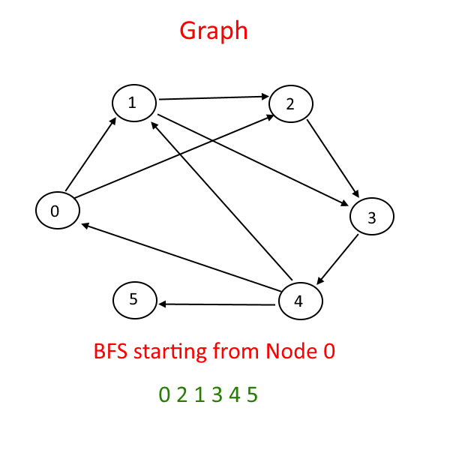
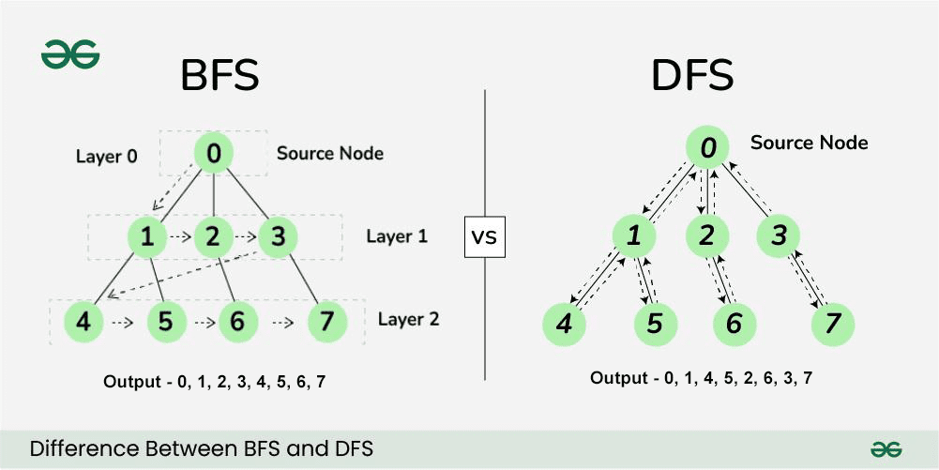
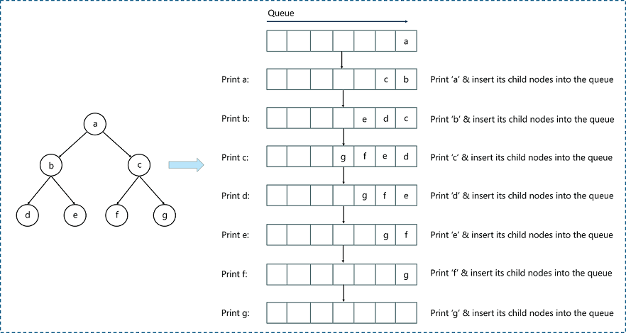
🔹 What is BFS?
Breadth First Search (BFS) explores:
- All neighbors at the current level
- Before moving to the next level
Think of BFS like:
“Check all nearby options first.”

🔹 How BFS Works
- Start from the root node.
- Visit all its neighbors.
- Then visit neighbors of neighbors.
- Continue level by level.

🔹 Data Structure Used
- Queue

🔹 Example
Same graph:
A
/ \
B C
/
D
BFS traversal:
A → B → C → D

🔹 Pseudocode
BFS(start):
create queue
mark start as visited
enqueue start

while queue not empty:
node = dequeue
for each neighbor:
if not visited:
mark visited
enqueue neighbor

🔹 Applications
- Shortest path in unweighted graphs
- Web crawling 🌐
- Social networks (friends suggestion)
- Level order traversal

🔹 Advantages
✅ Finds shortest path
✅ Complete (will find solution if exists)
🔹 Disadvantages
❌ Uses more memory
❌ Slower for large graphs

🔁 DFS vs BFS (Quick Comparison)
Feature | DFS | BFS
Traversal | Depth-wise | Level-wise
Data Structure | Stack | Queue
Shortest Path | ❌ No | ✅ Yes
Memory Usage | Low | High
Speed | Faster in deep graphs | Faster in shallow graphs

3️⃣ Hill Climbing Algorithm

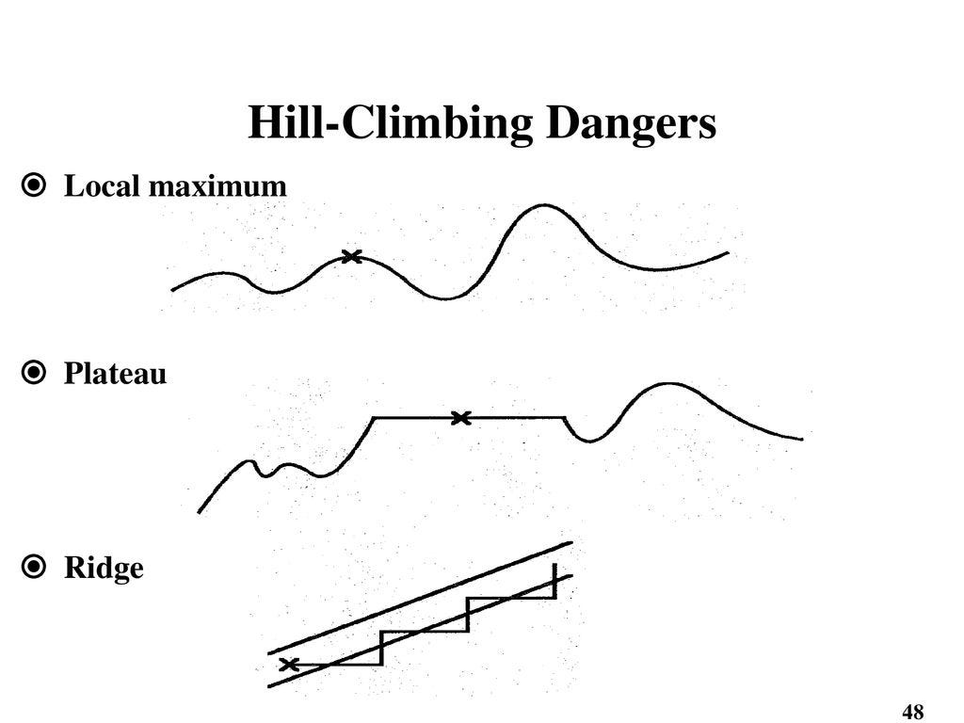
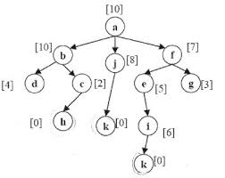
🔹 What is Hill Climbing?
Hill Climbing is a heuristic search algorithm that:
- Moves towards a better solution
- Chooses the best immediate neighbor
- Stops when no improvement is possible
Think of it like:
“Climbing a hill by always stepping upward.”

🔹 How Hill Climbing Works
- Start with an initial state.
- Evaluate neighboring states.
- Move to the neighbor with higher value.
- Repeat until no better neighbor exists.

🔹 Simple Example
Goal: Reach the highest peak
Current state → check neighbors → move to higher one
Stops when:
- No higher neighbor exists (local maximum)

🔹 Types of Hill Climbing
- Simple Hill Climbing – First better move
- Steepest Ascent – Best possible move
- Stochastic – Random better move
Day 32 – Advanced Concepts
Graph Search Algorithms
- Studied various techniques used to explore nodes in a graph efficiently:
  - Depth First Search (DFS) – Traverses deep into one branch completely before moving back to explore other paths.
  - Breadth First Search (BFS) – Visits all adjacent nodes first, progressing level by level through the graph.
  - Depth-Limited Search – A constrained form of DFS that stops traversal once a specified depth is reached, preventing infinite loops.
  - Bidirectional Search – Performs simultaneous searches from both the start and goal nodes, significantly reducing the search space.
Travelling Salesman Problem (TSP)
- Learned about TSP, a classic optimization problem.
- The objective is to determine the minimum-distance route that visits every city exactly once and returns to the starting city.
- Commonly applied in:
  - Transportation and logistics
  - Route optimization
  - Network planning
Principal Component Analysis (PCA)
- Explored PCA, a technique used for dimensionality reduction in data analysis.
- Reduces the number of features while preserving most of the meaningful information.
- Converts correlated input features into a new set of independent variables called principal components.
Principal Components Characteristics
- Ranked based on their significance.
- The first principal component captures the highest variance in the dataset.
- Each succeeding component captures the remaining variance and is orthogonal to the previous components.
Mathematical Foundation of PCA
- Based on linear algebra concepts such as:
  - Covariance matrix
  - Eigenvalues
  - Eigenvectors
- Eigenvalues indicate how much variance each principal component holds.
- Eigenvectors define the direction of the transformed feature axes.
Advantages of PCA
- Reduces computational cost.
- Eliminates noise and redundant features.
- Helps visualize complex, high-dimensional data in 2D or 3D space.
- PCA is widely used as a preprocessing step before machine learning model training.
- It is an unsupervised learning technique, as it does not rely on class labels.

Day 33
- Continued development work on the project.

Day 34
- The mentor explained the objectives and requirements for Milestone 4.
- Participated in a feedback and discussion session.
- Progressed further with project implementation.

